Technical Specification/ Criteria
Tender for: Solar Panel installation
Name of Project: Solar Panel installation
Tender Reference: BGD/DHK/Solar/TENDER/2023/004

Annex-4
Please review this Table and other specifications before answering the following questions

Equipment | Specifications | Additional Technical Evaluation Indicators
Area | 2454 Sqft or 227.98 Square M
System Capacity and PV Solar Panels | 18kWp (kW peak) system along with 10kWp for backup system. All total a 28 kWp system. Minimum 18% efficient (monocrystalline), tier-1 branded.  Compatible with SREDA standards and listed on their webpage | Efficiency (%), Coefficient of temperature (%/degree C), Power rating / sq metre
Grid Tied Inverter | String inverter, 15 kW, 3-phase, 50 Hz, Compatible with SREDA standards and listed on their webpage | Inverter efficiency (%), Operating temperature parameters
Hybrid Inverter | Grid Tied hybrid inverter,3.5x3 = 10.5 kW, 50 Hz | Inverter efficiency (%), Operating temperature parameters
Battery Bank | 12 volt 200amp battery, total 12 individual battery. (4 individual battery will be combined to make a 48 volt unit, total of 3 unit. Each 48 volt unit will be connected to separate hybrid inverter) | AGM Lead Acid, Operating temperature parameters, discharge capacity
Mounting Structure | Panels mounted on office roof at an angle of 23 degrees to the horizontal. (see the design in the following figures) | Allowing access walkways for maintenance, inspections, etc.
Cables, Cable Tray, Combiner Box | Wire needs to be capable of carrying high amps and fire resistant. The combiner box needs to be IP65 rated. | For DC and AC there will be different requirement of wire rating and category but both need to have 25% extra load capacity.
Fuel check controller | A controller which will combine the solar and generator electricity supply. This will maintain the balance in power supply from both generator and solar system when national grid is offline. | Supplier will ensure required controller which support both solar panel and diesel fuel generator
Status Monitoring Tools | The monitoring tools needs to be connected to a computer or a software where the relevant information will be stored. | Status monitoring tools is to be used for tracking the solar production over time. Also, monitoring equipment will be used for seeing if any part of the solar panel is malfunctioning.
Lightning Protection System | With resistance < 5 ohms
AC/DC Components | IP65 rated and fire resistant
Equipment for Maintenance | No specification
Net Energy Meter | SREDA and BSTI approved
Construction works |  | Access walkways, protective fencing
Getting regulatory permissions and others

Other specifications are-
- Solar panel- Solar panel must be from following list in the given webpage link- https://solar.sreda.gov.bd/nem/solarmodule.php
- Grid tied Inverter- Inverter must be from following list in the given webpage link- http://sreda.gov.bd/site/page/ef10447e-509a-4e7d-94ad-df2eaf5c27ec
- Net Energy meter- Product must be from the list of product approved by SREDA. Net meter list-https://solar.sreda.gov.bd/nem/gridtiedinverter.php

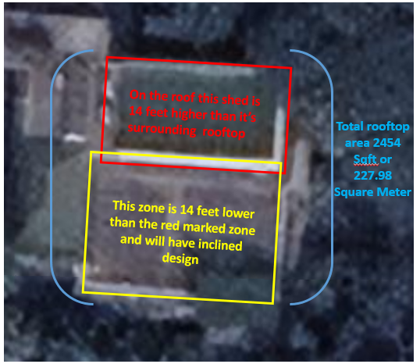
Figure 1: Rooftop top vie

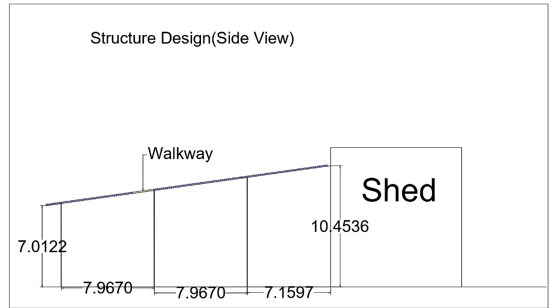

Figure 2: A hypothetical design structure for the solar panels (The side view is for the lower rooftop zone which is marked as the yellow zone in figure 1)

